|  |  |  |
| --- | --- | --- |
|  | **Rochester Institute of Technology**  **Golisano College of Computing and Information Sciences**  **School of Interactive Games and Media**  **2145 Golisano Hall – (585) 475-7680** |  |

**Data Structures & Algorithms for Games & Simulation II**

**IGME 309**

**Concentric Circles**

This exercise follows lecture D05

1. In the root of the repository look for the example execution under _Binary. It will look like this:

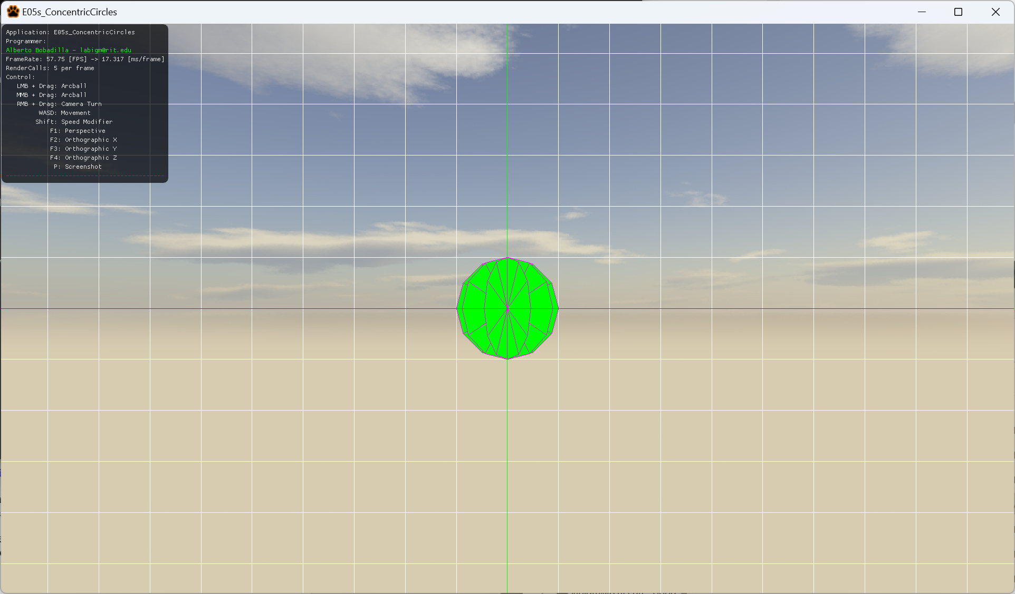

1. For this exercise you will create a dynamic number of circles that will share an origin point, you may create the circles calculating by trigonometry or use a rotation matrix from glm to arrange the new circles. It is up to you to ideate the solution for the exercise. Remember you will be using a method that uses this signature:

void GenerateCCircles(float a_fRadius, int a_nSubdivisions, int a_nCircles, vector3 a_v3Color);

The number of subdivisions as you can see is the same number of triangles and the radius is how large is the circle, along with the color of the shape. The number of circles you can see in a full revolution around the origin is a_nCircles

1. All your code will be coded in the mesh.cpp file in said function so this is the only file you need to submit to the dropbox in MyCourses, please do not zip this file.

